|  |
| --- |
|  |
| Requirements Specification (RS) |
| SERVICE BID PROJECT |

|  |
| --- |
|  |

Requirements Specification (RS)

Document Control

Revision History

|  |  |  |  |  |  |
| --- | --- | --- | --- | --- | --- |
| **Date** | **Version** | **Scope of Activity** | **Prepared** | **Reviewed** | **Approved** |
| 14/10/2005 | 1 | Create | AB | X | X |
| 21/10/05 | 2 | Update | CD |  |  |

Distribution List

|  |  |  |
| --- | --- | --- |
| **Name** | **Title** | **Version** |
| Eugene McLaughlin | Lecturer |  |
|  |  |  |
|  |  |  |
|  |  |  |
|  |  |  |

Related Documents

|  |  |
| --- | --- |
| **Title** | **Comments** |
| Title of Use Case Model |  |
| Title of Use Case Description |  |

**Table of Contents**

1 Introduction 3

1.1 Purpose 3

1.2 Project Scope 3

1.3 Definitions, Acronyms, and Abbreviations 5

2 User Requirements Definition 5

3 Requirements Specification 5

3.1 Functional requirements 5

3.1.1 Use Case Diagram 6

3.1.2 Requirement 1 <SIGN IN> 6

3.1.3 Requirement 2 <OFFER JOB> 8

3.1.3 Requirement 3 <MAKE BID> 10

3.1.3 Requirement 4 <ACCEPT/ CONFIRM BID> 11

3.1.3 Requirement 5 <PAYMENT> 13

3.2 Non-Functional Requirements 14

3.2.1 Performance/Response time requirement 14

3.2.2 Availability requirement 14

3.2.3 Recover requirement 14

3.2.5 Security requirement 14

3.2.6 Reliability requirement 14

3.2.7 Maintainability requirement 15

3.2.8 Portability requirement 15

4 GUI 15

5 System Architecture 22

6 System evolution 22

# Introduction

This document give you a better understanding of how the layout of a project is regarding the software requirement needed to implement tasks involved in creating the project from the very beginning to the end product. It’s like a road map to your destination without this the project would run out of ideas in the direct that is needed to finish all application. It’s a clear blueprint to success.

## Purpose

In our lives, we are all rushing around today between work and our family life whether it doing the shopping or bringing the children to school. So time is very important element to us but it something prevents us in getting essential items cheaper regarding the daily household budget, whether its comparing the prices of goods and services at the local supermarkets, getting fuel for heating the home or running the car and with the price of car insurance going up within the last two years. We must think smartly about cutting our overhead, so that we may use it in a more beneficial way, whether this is so we can enjoy area that we couldn’t afford spending on before with the likes of going on holiday or putting saving away to educate our children. I could seat down all day and mention a load of different products and services that we could avail of cheaper today.

We as consumers tend to settle with the price we are first given from the retailer. What if I said to you that I can provide one area that might save you money and that you the consumer were in control of the situation and had the choice to pick what you think will suit you. Maybe you would laugh about this and say this can’t be done.

Well you my laugh but this application will do this. Now I have you attention.

Service Bid will put the power back into your hands and save you time and money trying to do without this application.

The application will basically allow you to service your vehicle at a considerable lower price than you currently get at your local dealer by the way of being overcharged.

Everybody that has a vehicle can avail of this application.

## Project Scope

The scope of the project is to develop a response web application that allows consumer to post online work regarding the servicing of their vehicle. Once the customer posts the online work, this will be sent out to the garages around there local area.

Each garage can then response with an offer regarding carrying out the service or repairs to the vehicle.

This gives the consumer the choice which has being lacking in this sector of the market place but it also cuts out time lost and save you money in the long term.

The motivation for me was to see an area that offer so much more that overcharging of the consumer and getting poor customer satisfaction with the likes of adverts on television and radio about certain garages offering service deals that seem to be too good to be true but isn’t really.

In my knowledge of servicing my own car and the cost and time to do this, I see that this area can be reduce for the consumer but this wasn’t the only factor that convinced me. One day I was talking to friend and he was telling me about the cost of getting his car repaired at a main dealers and the poor customer service that he encountered. So this was the inspiration that inspired me to come up the idea to help the consumer to save money and time.

The application will give you the opportunity to registration as a Consumer or Dealer. Both will have different layout screen regarding the graphical user interface.

The Consumer will fill out a form that will ask you to enter details of certain aspects of the car and a brief description of the work need to be carried out and then the consumer posts this online.

The Dealers receive this information and then can response with an offer.

The Objectives is to give the user the opportunity to have an application that will allow them to receive lower option of pricing regarding the servicing of your vehicle and giving the garages work they may have never got through the normal avenues.

The Criteria is to provide a user friendly application that is not too complex to use and gives the user a wonderful experience of reaching out to garages that would normal take a couple of days to get quotations. I hope to have a fully functional application that the user will benefit from and promote the product to the wider community to enjoy.

The project expectation is to provide a fully functional application when finished so that it meets the approval of the users and to encourage new users to use the application. .

The project restriction is that a user must create an account to enter the application as data protection of personal information is very important and can be a high risk factor that must be protected. So it’s important that we secure the information from being hacked and used in a harmful way. In providing a clear set of rules that will be implemented to whether it’s.

The risks involved are very simple that the general public reject the application but like any business there is no guarantee in a start-up business that will take off. Of course the cost of setting up and the promotional side and the investment from outside is a risk with any venture. Another risk is the security of personal information stored in the database so this must be protected at all times. The application will use a secure payment system known as PayPal that gives the user the peace of mind regarding secure payment.

The project supposition is that the developer believes that this application can sell to the general public at this current time based on there being no application on the market today.

The Contingency plan is to use github as a version control so that if anything goes wrong within the application that you have a numbers of different version that you can rollback at any time. So if you have any conflicts within the application and can’t fix them at the time it gives you an option to go back to the last version that was working.

The human resource that will be used will be the general public to test the application and fill out a census form on what they thought on the application.

## Definitions, Acronyms, and Abbreviations

API – Application Programming Interface

# User Requirements Definition

The user requirements are the step by step approach to understanding what is require within the application, just as if you were using an app on your phone there are different sections within the application, whether it’s going from the sign in screen to the home screen and going to different screens within the application. We must plan the requirements to enter into the responsive web application were we make it easy to use and friendly for all ages giving of any but also meets their needs.

# Requirements Specification

This gives you a detailed specification of all the different components within each use case. In doing this it gives the user the better understanding of how each component works within the layout of the screen. This helps both the developer and consumers to understand how it works in the design element of each requirement specification within the use case. By the way of testing the components before entering the market it is tested for errors.

## Functional requirements

The functional requirements is a guide to how your application work in regards to the software system whether certain functionality within the system works for example sign in or going to different screens went you click a button or enter some information into the screen and submit it, all these different aspects must be fully functional before it goes to lives. The registration and the sign in are the most important function requires for the application otherwise the user can’t avail of the application and becomes useless.

### Use Case Diagram

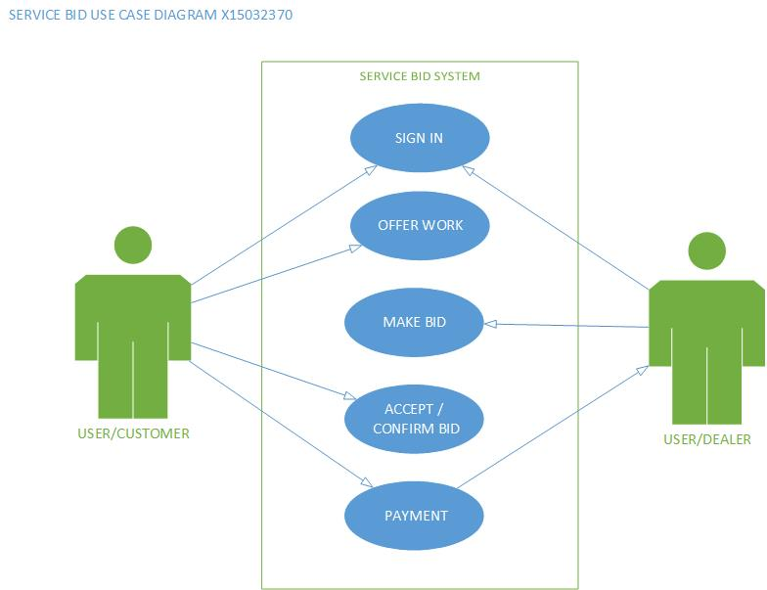

### Requirement 1: “User Sign in”

#### Description & Priority

The User will need to have an account to access the website so they can use it. They must enter their own personal unique identifier by the way of a username and password to account their own account. If they are a first time user they must create an account by the way of filling out an online registration form and once this is done. They are asked to sign in like all existing users.

#### Use Case

#### 

**Scope**

The scope of this use case is to allow the user to enter their account on the application

**Description**

This use case describes the correct procedure of how enter their own account by the way of set of instructions to be followed and if the procedure is incorrect. The user has option to reset their details to gain access to the account.

**Flow Description**

**Precondition**

The system is idle

**Activation**

This use case starts when a user clicks on the website

**Main flow**

1. The User enters the URL in to the browser.
2. The User click the enter button.
3. The System returns with the Home Screen of the application**.<A1>**
4. The User then clicks on the Sign in button.
5. The System returns the Sign in Screen.
6. The User must enter the sign in details.
7. The User clicks the Submit Button.
8. The System verifies the details**.<E1,E2>**
9. The System allows access to the user account of the application.

**Alternate flow**

A1: **The User Register a new Account**

1. The new User clicks on the registration button of their choice.
2. The system returns the registration screen.
3. The User must enter personal details on the online form.
4. The User enters personal details.
5. The User then clicks the submit button.
6. The System stores the information.
7. The System returns a message for the user to sign in.
8. The User clicks on to the Sign in screen.
9. The User enters the personal details.
10. The system response with access to the users account.

**Exceptional flow**

E1: **Incorrect User Sign in Details**

1. The user enter in the email address and password
2. The system returns with incorrect details
3. The system asks the user to re-enter password
4. The system gives you 3 attempts to re-enter password
5. The system allow access if correct password gain entry.
6. The system will locks out if unsuccessful **<E2>**

E2: **Reset User Sign in Details**

1. The user must click the reset password button on the log-in screen.
2. The system asks for an email address.
3. The user enters email address.
4. The user clicks the submit button.
5. The system sends an email with a link to reset password.
6. The user clicks on the web page link.
7. The system shows the screen to reset the password.
8. The user enters new password.
9. The user clicks the submit button.
10. The system returns the user to the log-in of the main flow.

**Termination**

The application terminates when the user signs out.

**Post condition**

The system goes into a wait state.

### Requirement 2: “Offer Work”

#### Description & Priority

The Customer will sign in to their account and fill out the form to post online work needed to be carried out on their vehicle.

#### Use Case

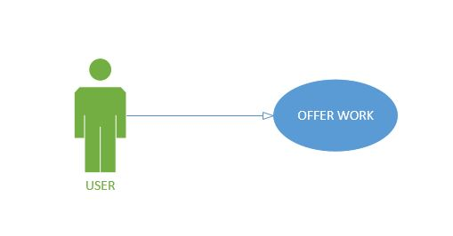

**Scope**

The scope of this use case is to allow the customer to enter the application and tender out work regarding their vehicle.

**Description**

This use case describes how the user follow a set of instructions to post work online to dealer for work needed to be carried out.

**Flow Description**

**Precondition**

The system is running

**Activation**

The use case starts when the user clicks on the sign in button and enters the online form.

**Main flow**

1. The Customer fills out online form
2. The Customer clicks the submit button
3. The System sends the job offer
4. The Dealer receives the job offer **<E1>**
5. The Dealer makes a bid. **<A1>**

**Alternate flow**

A1 : **<Rejects Job Offer>**

1. The Dealer rejects the job offer
2. The Dealer click on the reject button
3. The System sends a decline message to the Customer.

**Exceptional flow**

E1 : **<Information Needed Regarding Job>**

1. The Dealer replies with Need more information
2. The Dealer clicks the submit button
3. The System sends the message
4. The Customer response to the garage.
5. The System sends the response
6. The Dealer then choices make a bid or not

**Termination**

The user terminates the system when they sign out.

**Post condition**

The system goes into a wait state

### Requirement 3: “Make Bid”

#### Description & Priority

The use case describes how the dealer can make an offer for work available online.

#### Use Case

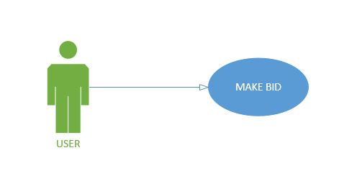

**Scope**

The scope of this use case is to allow the dealer to bid for work that is available online that is then sent to the customer.

**Description**

This use case describes the how the dealer makes an offer to the customer regarding work that’s post online from the customer

**Flow Description**

**Precondition**

The system is running

**Activation**

This use case starts when the dealer access the garage account.

**Main flow**

1. The Customer fills out the job offer
2. The System sends out offer
3. The Dealer response by making an offer
4. The Dealer click the submit button
5. The Customer accept offer by clicking on accept button. **<A1>**
6. The Dealer receives confirmation of job offer

**Alternate flow**

A1 : **<Rejected Bid>**

1. The Dealer bid is rejected
2. The Dealer puts in new bid
3. The Customer accept new bid **<A2>**
4. The Dealer receives confirmation of bid accept

A2 : **< Bid Withdrawn >**

1. The Customer rejects new bid
2. The Dealer withdraws bid by click withdrawn button.

**Exceptional flow**

None

**Termination**

The system is terminated when the user sign out.

**Post condition**

The system goes into a wait state

### Requirement 4: “Accept / Confirm Bid”

#### Description & Priority

The customer is offer a number of quotations from different dealers regarding work needed to be carried out. The customer decides which offer is suitable to them and they select the one and get a confirmation email from the dealer booking in the vehicle for the work to be carried out.

#### Use Case

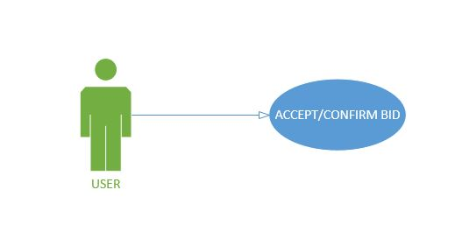

**Scope**

The scope of this use case is to give the user to accept and receive confirmation of job to be carried out the dealer that the customer has selected.

**Description**

This use case describes the how the offer from the garage is being accepted and the confirmation is being sent to the dealer

**Flow Description**

**Precondition**

The system is running

**Activation**

This use case starts when customer is logged into their account

**Main flow**

1. The Customer receives bid
2. The Customer accepts bid by clicking accept button **<A1><A2>**
3. The System sends confirmation of job offer to Dealer.
4. The Dealer receives confirm of job.
5. The Dealer click confirm button

**Alternate flow**

A1 : **<Rejects Bid>**

1. The Customer rejects offer by click the reject button
2. The Dealer receives failed bid.
3. The Dealer makes new offer
4. The Dealer clicks the submit button
5. The Customer accepts new bid
6. The Customer clicks accept bid
7. The Dealer receives confirmation of bid accepted.

A2 : **<Bid Withdrawn>**

1. The Customer rejects bid by clicking the reject button
2. The Dealer withdraws bid by clicking Withdrawn button

**Exceptional flow**

None

**Termination**

The system is terminated when the user signs out.

**Post condition**

The system goes into a wait state

### Requirement 5: “Payment”

#### Description & Priority

The use case describes how the customer confirms the offer from the garage by sending confirm with booking deposit.

#### Use Case

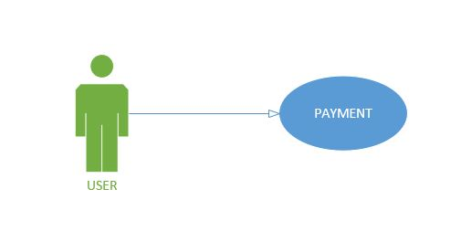

**Scope**

The scope of this use case is to make a booking deposit to the dealer to confirm that job offer

**Description**

This use case describes the how the customers confirm the offer and forward on the deposit to the dealer regarding the job offer

**Flow Description**

**Precondition**

The system is running

**Activation**

This use case starts when the bid is accepted by customer

**Main flow**

1. The Customer accepts bid
2. The Customer clicks pay button
3. The Customer fills out payment form.
4. The Customer click on pay now button
5. The System confirm payment has gone through **<A1>**
6. The Dealer receives booking deposit.

**Alternate flow**

A1 : **<Payment Failed>**

1. The System return payment failed
2. The System ask to re-enter card details
3. The Customer re-enter details
4. The Customer clicks the submit button
5. The System confirms payment **<A2>**

A2 : **<Card Payment Rejected>**

1. The System declines payment
2. The System as delete booking.

**Exceptional flow**

None

**Termination**

The system presents the next ……….

**Post condition**

The system goes into a wait state

## Non-Functional Requirements

The non-functional attributes required by the system are:

### Performance/Response time requirement

The latest technology will be used to give excellent performance and response times with the speed of high quality broadband speeds available

### Availability requirement

The availability depends on the access of a personal computer, laptop, tablet or smart phone but also the availability of the internet system working in your area at the time of trying to access the application

### Recover requirement

The system will have a backup system that if anything happen to the system it automatic reboot to that system, so that the user cannot lose an important information if the system crashes.

### Security requirement

The system will use the latest security software available regarding identification and authentication system the create the user to registration by using personal identification and a unique password

### Reliability requirement

The system reliability will depend on the latest broadband speeds available at the time the system is being used.

### Maintainability requirement

The system will be kept updated with the latest software system updates by the system administrator regarding the latest technology on the market at the time.

### Portability requirement

The requirement is to make this a responsive web application so that this application can be used anywhere and at any time with a laptop, tablet and smartphone.

# GUI

The GUI is the term known as Graphical User Interface. What does this mean to the person that doesn’t understand the term? Basically it means that whatever you see on your laptop or any other device that is shown you a screen are called a GUI. It interacts with the user to give you a visual display of the website. The screens are in different sizes and give the user very enjoyable experience regarding using the website.

The Attributes can give you different layout of the screen depending on what the user is looking for between clicking a button to bring you to different screens and give you options to do different things within the Screen.

The mock-ups below gives you the first idea of what the website might look like but overtime this may change due to design elements within the project once it’s finished.

**MAIN HOME SCREEN:**

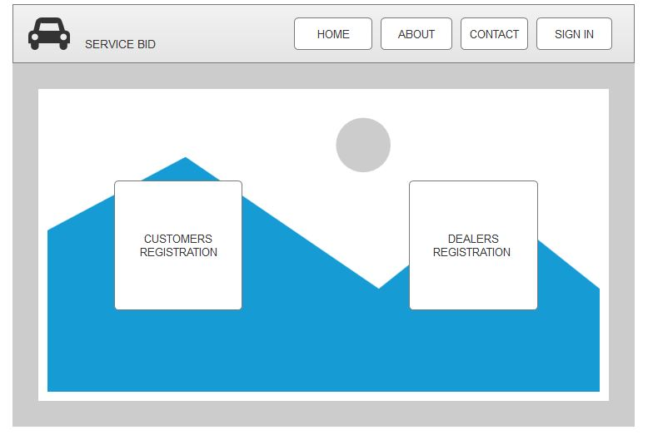

**NEW CUSTOMERS REGISTRATION FORM:**

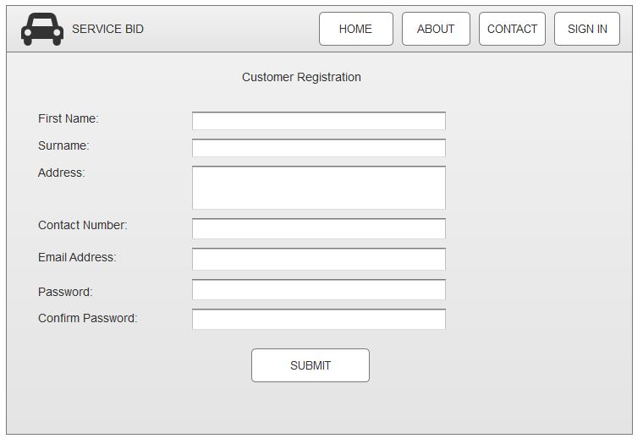

**DEALERS REGISTRATION FORM:**

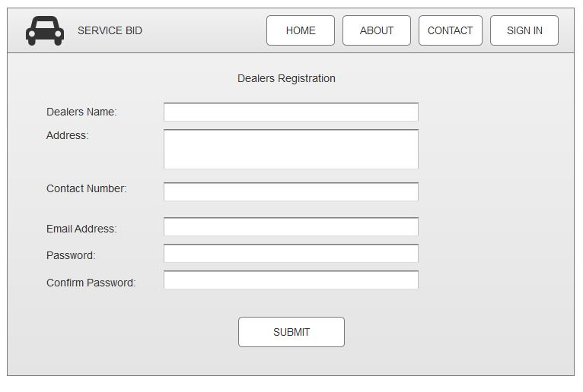

**SIGN IN SCREEN**

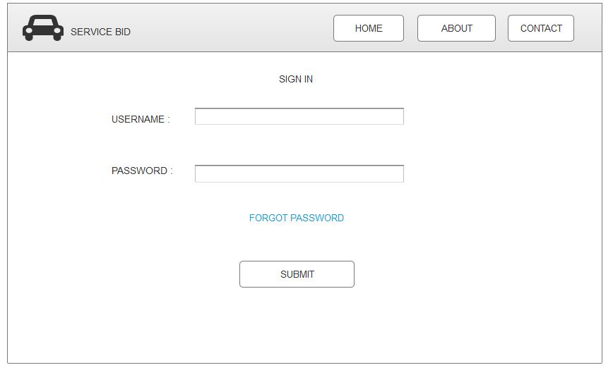

**CUSTOMER HOME SCREEN**

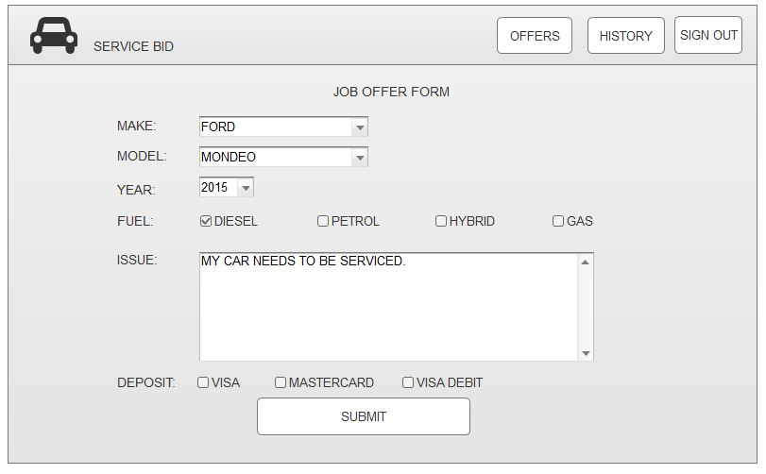

**BIDS FOR DEALERS SCREEN**

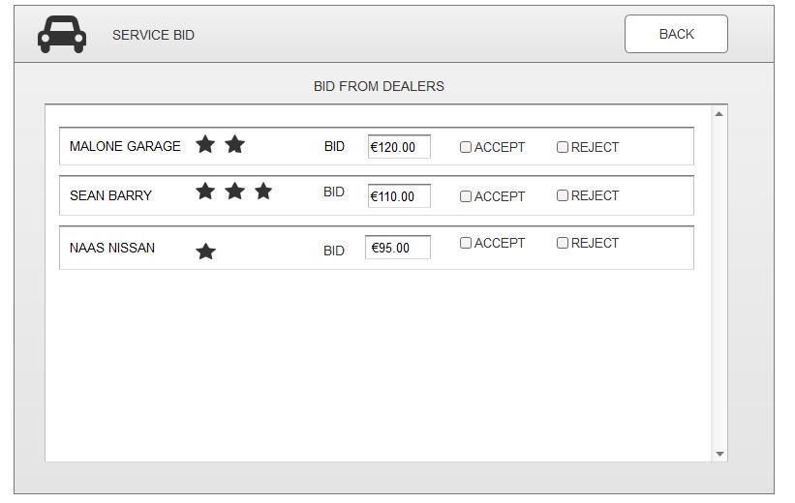

**PAYMENT DETAILS**

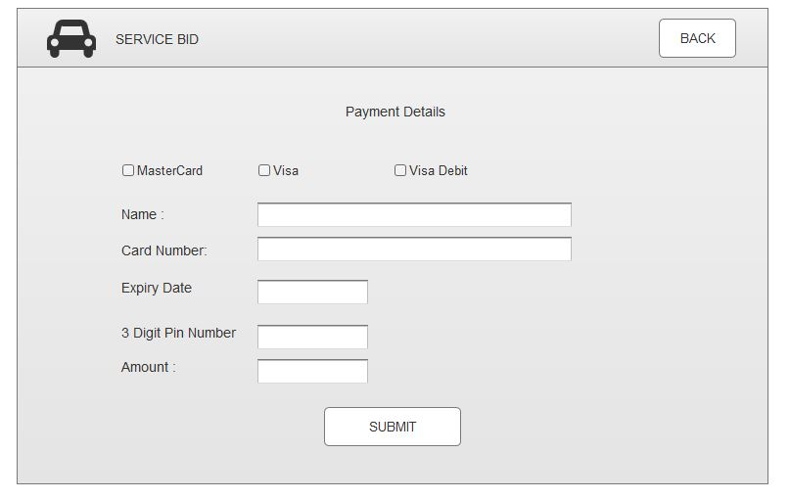

**JOB CONFIRMATION**

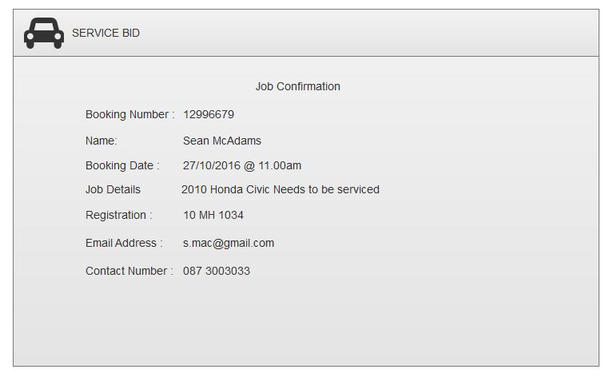

**CUSTOMERS HISTORY TRANSACTIONS SCREEN**

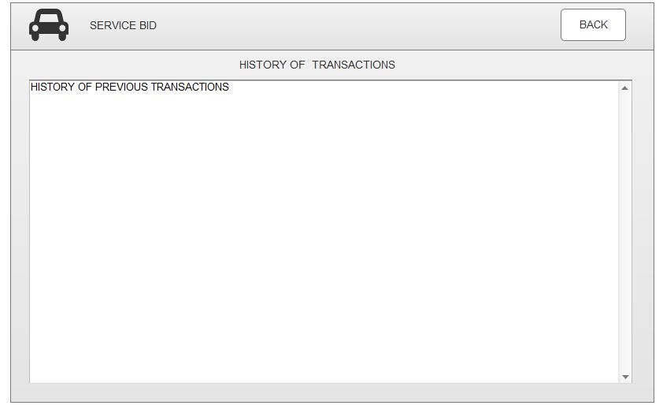

**THE DEALER HOME SCREEN**

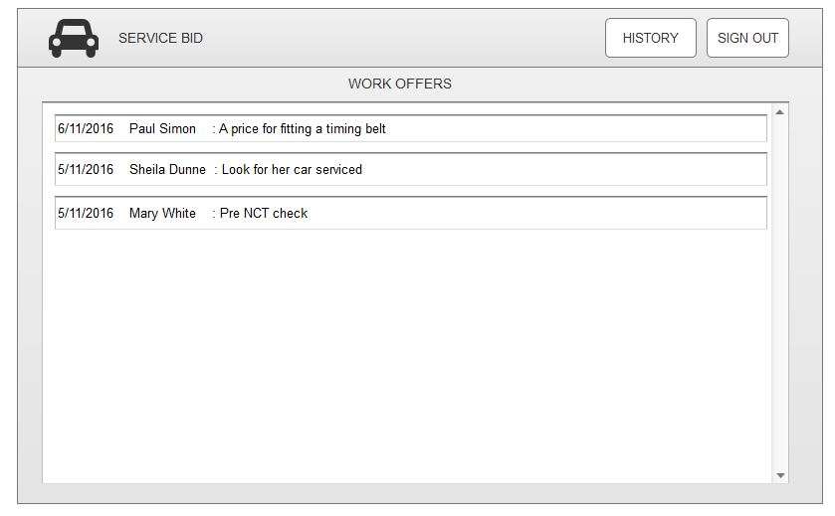

**DEALER RECIEVES CUSTOMERS JOB SCREEN**

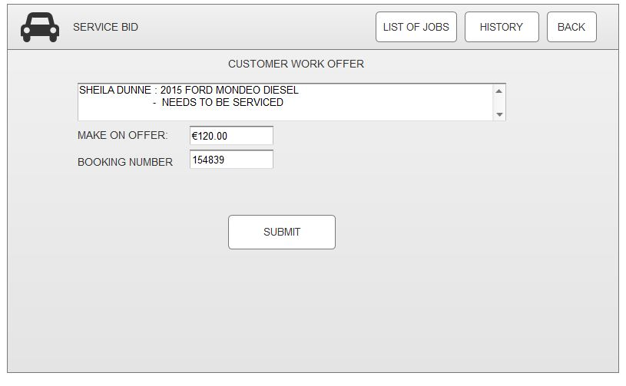

**DEALER RECEIVES CONFIRMATION OF CUSTOMERS JOB SCREEN**

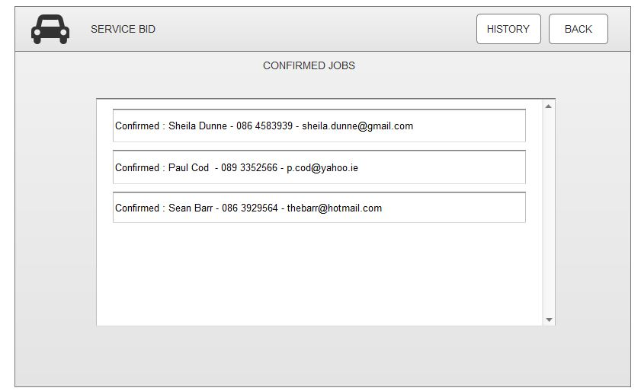

**DEALERS HISTORY TRANSACTION SCREEN.**

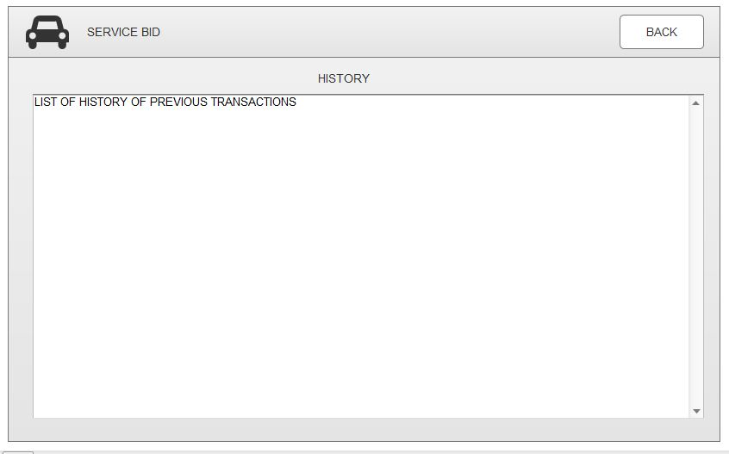

# System Architecture

The system architecture shows how to go about programming the application and their association with each process.

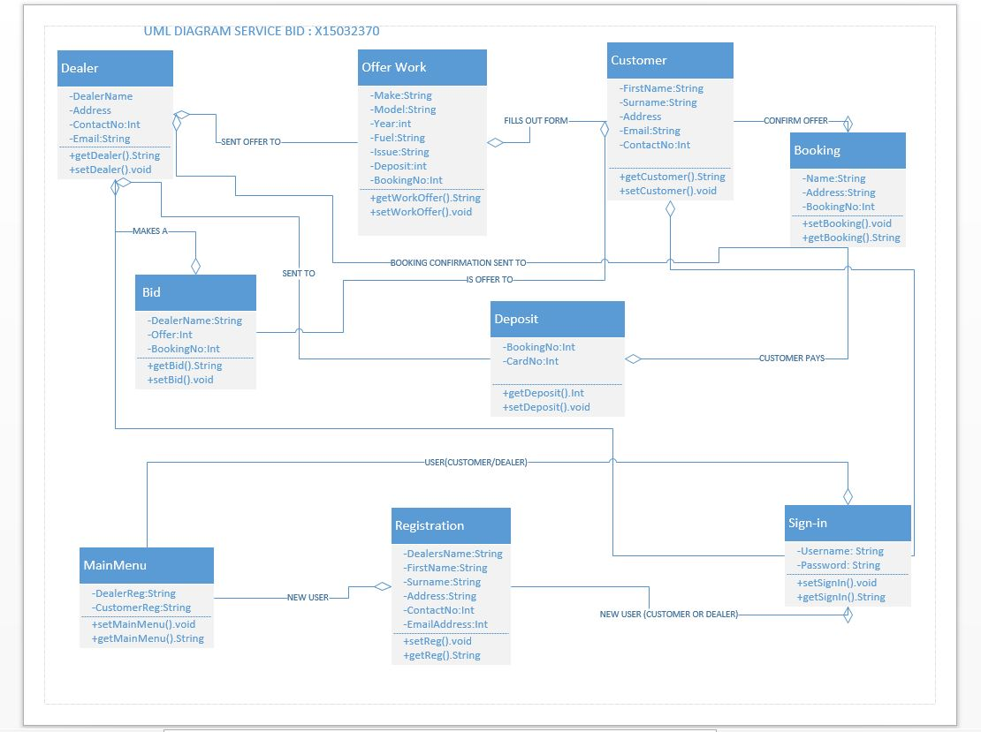

# System Evolution

This application has the potential to be used globally, as the majority of family’s have vehicle. This application will reduce the cost and time for searching around for better deals regarding servicing and repairing to your vehicle. This application will evolve overtime with more development to be a very useful tool in searching for a quality service at a reasonable price. There is no application like this on the market today and the response is clearly positive for the feedback from students. This application puts the power back into the customers rather than the dealers being in control and overcharging their customers.